**API Documentation**

**1. Create a new API and add collection or click on the collection options and click on view documentation**

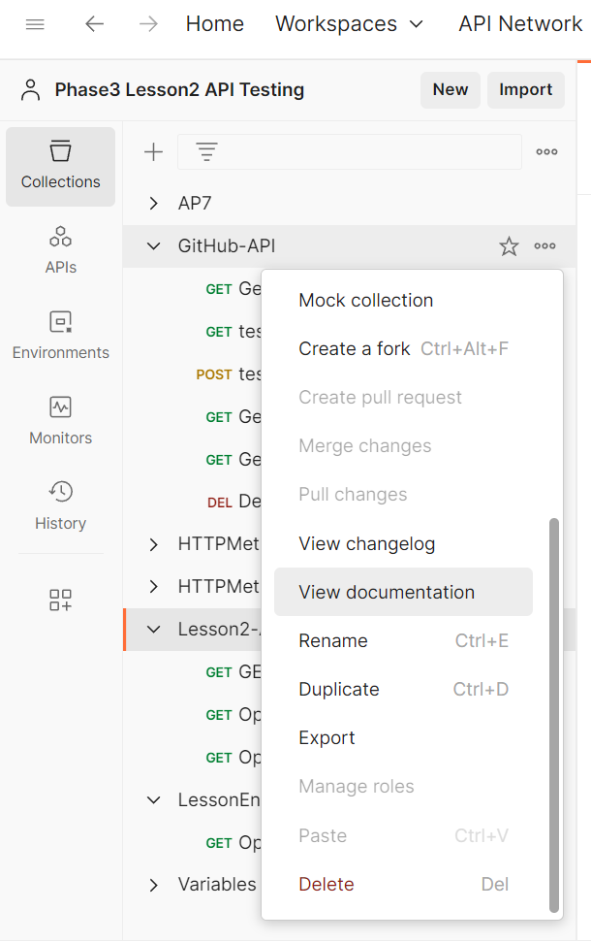

**2. Descriptions for collection and requests can be added**

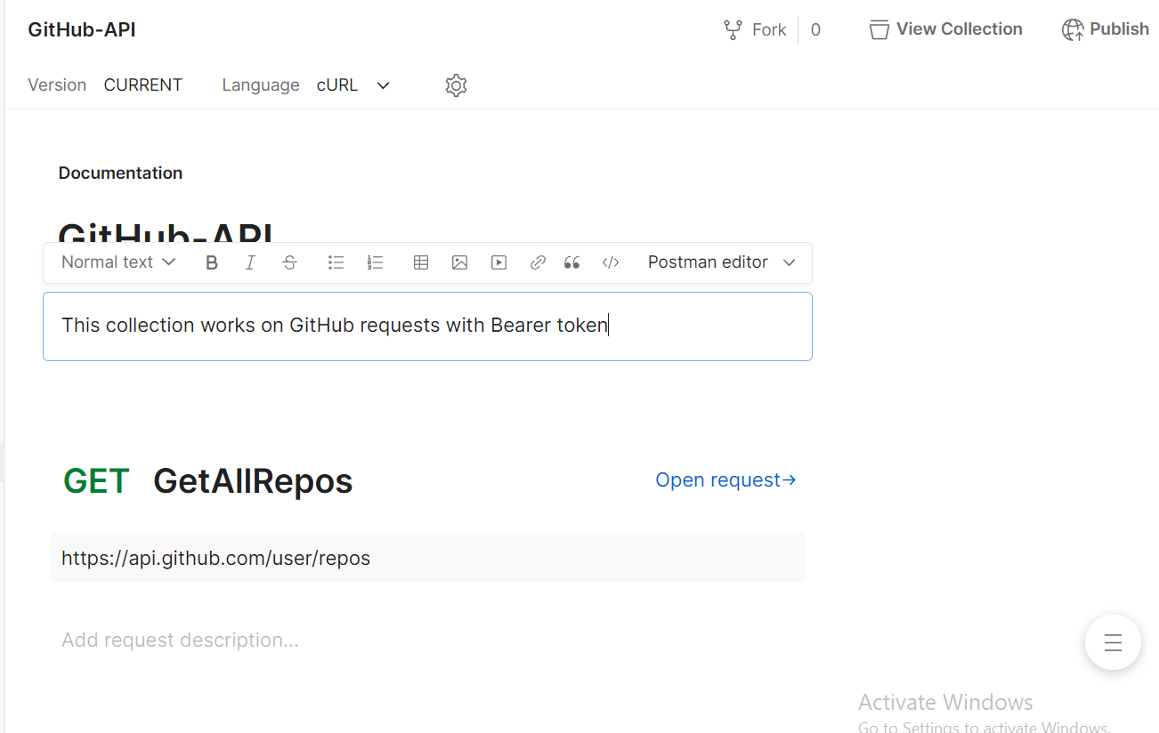

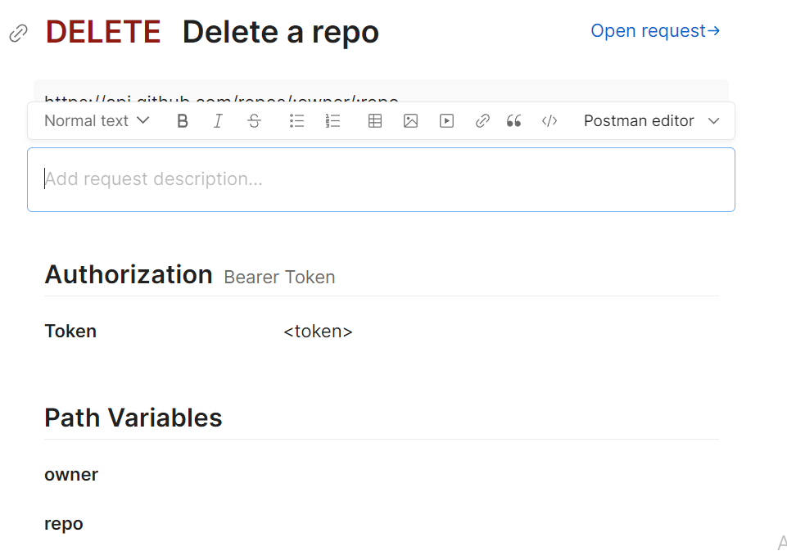

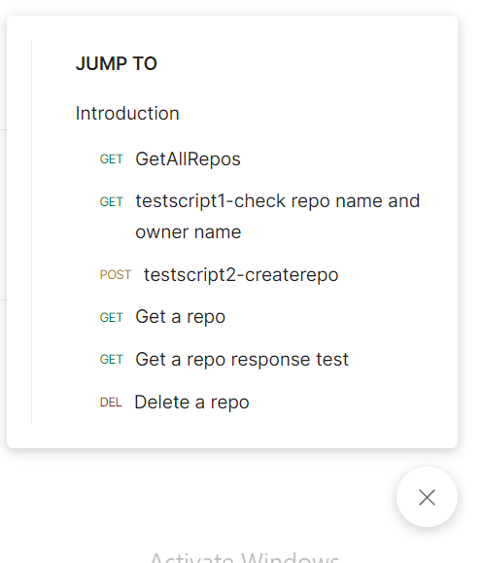

**3. Complete documentation can be viewed anytime by clicking on this link**

